

**Sehrish Mubarik**

**BSAIM-F23-001(4A)**

**Assignment no 04**

**Submitted to:**

**Sir Rasikh ali**

**Lab task 01**

**Question no 01**

**House price prediction**

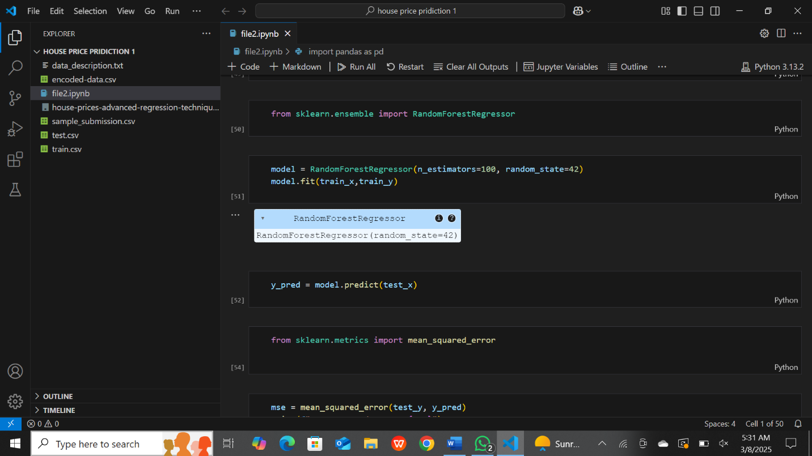

**Description**

It begins by importing essential libraries such as pandas and numpy for data manipulation, along with pickle for model serialization. The notebook also utilizes machine learning tools from sklearn, including randomforestclassifier for classification, LabelEncoder for categorical data preprocessing, and train_test_split for dataset partitioning. The dataset, named train.csv, is loaded and analyzed, displaying its structure in terms of rows and columns. The project likely involves training a classification model and evaluating its performance using accuracy_score. The notebook follows a structured approach to preprocess data, train an SVM model, and assess its accuracy, making it a well-organized workflow for a classification task.

**Kaggle submission**

